Chemistry

Unit 4

Area of Study 7 Test Answers:

Biochemistry

Section 1: Multiple choice (12 marks)

Question 1

A The bond between C=O and N–H groups on nearby, regularly spaced peptide links causes the helical shape.

Question 2

C Tyrosine and tryptophan contain delocalised electrons

Tyrosine and tryptophan both contain aromatic benzene rings, which contain delocalised electrons. Option A is false, because methionine has a polar side chain. Option B is false, because proline does not have a side chain capable of forming hydrogen bonds. Option D is false because alanine is a non-polar amino acid.

Question 3

A The reaction involves formation of peptide links between the carboxyl group of one amino acid and the amino group of another.

Question 4

C The hydrogen bonds between the amide C=O and N–H on the peptide backbone.

Both alpha-helices and beta-pleated sheets are held together by the hydrogen bonds that form between the C=O and N-H atoms on the peptide chain of adjacent polypeptide chains.

Question 5

B (165 + 131 + 149) − (2 × 18) = 409

Two water molecules are formed as by-products of the condensation.

Question 6

C An enzyme is said to be denatured when its primary structure is disrupted

Enzymes are denatured when the non-covalent bonds that hold their tertiary and secondary structures together are broken. If the primary structure of an amino acid is broken, it is through a hydrolysis reaction, rather than denaturation.

End of section 1

Section 2: Short answer (15 marks)

Question 7

a Tyr–Gly–Gly–Phe–Met

(1 mark for including 5 amino acids)

(1 mark off for each amino acid incorrectly identified)

b

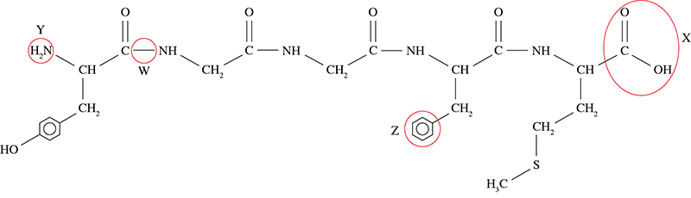

(4 marks)

Question 8 (4 marks)

a

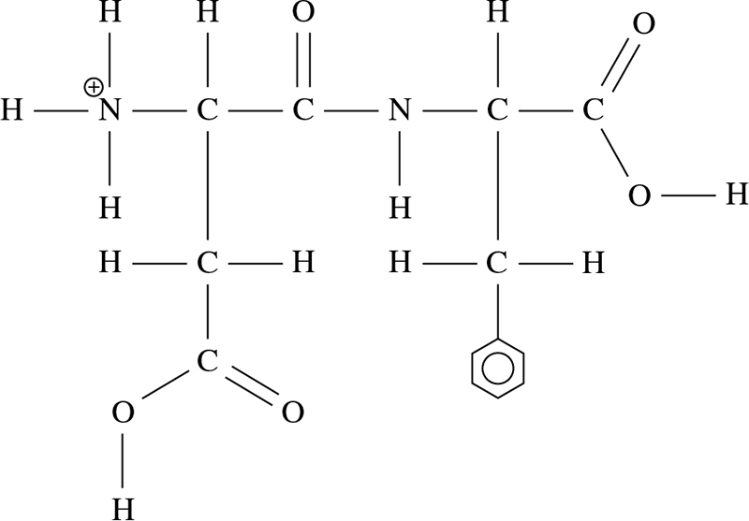

(2 marks)

b Structure 1

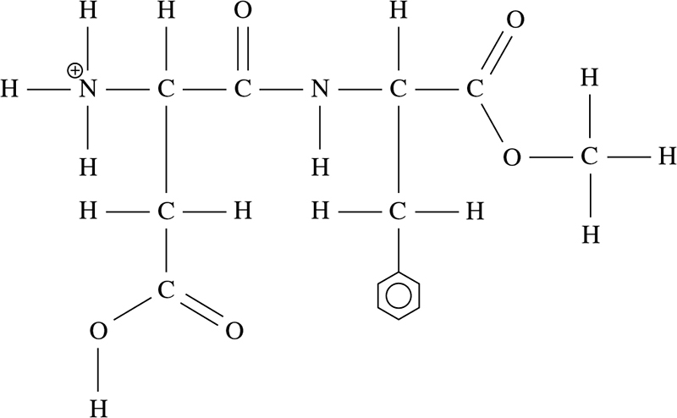

Structure 2

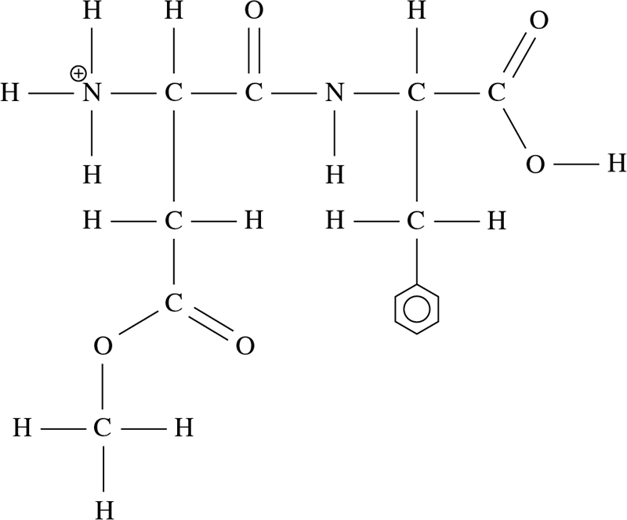

(2 marks)

Question 9 (4 marks)

Advantages: (2 marks)

• Lower energy consumption as can operate at much milder temperature and pressure conditions.

• Are specific to one reaction. No side-reactions will occur.

Disadvantages: (2 marks)

• Very sensitive to changes in pH and temperature.

• Difficult to separate the enzyme from the reaction mixture to recover the product.

End of section 2

Section 3: Extended answer (21 marks)

Question 10 (7 marks)

a \*

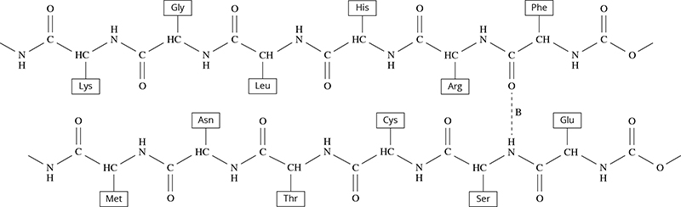

b i hydrogen bonding\*

ii \*

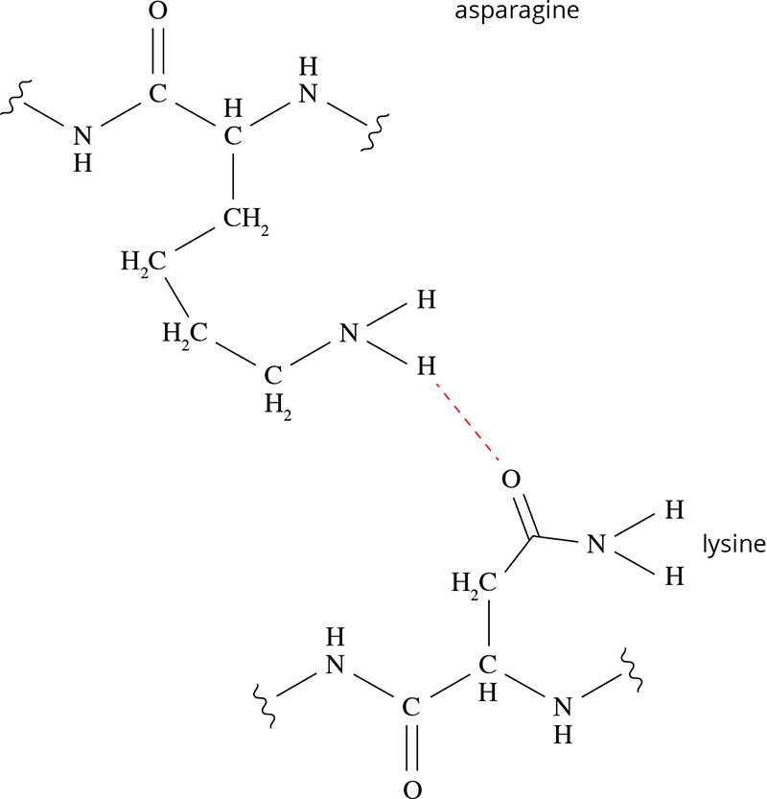

c In acidic conditions, the side chains of several amino acids become protonated. \*

This affects the type of interactions that they can have with other side chains, leading to protein unfolding or denaturation, when the tertiary structure is lost.\*

For example, at low pH, the NH2 groups of both lysine and arginine will become NH3+ groups.\*

This will cause repulsion of these side chains, rather than their attraction by hydrogen bonding.\*

Question 11 (14 marks)

a Hydration of ethene: (2 marks)

CH2CH2 + H2O → CH3CH2OH

Fermentation of glucose: (2 marks)

C6H12O6 → 2CH3CH2OH + 2CO2

b Rate:

• A high temperature increases the rate of reaction

• By increasing the kinetic energy of reactant molecules and hence the frequency of   
collisions\*

• By increasing the proportion of reactant molecules with sufficient energy to react\*

• A high pressure increases the rate of reaction

• By increasing the number of particles in a given area and hence increasing the frequency of collisions\*

Yield:

• A high temperature favours the reverse reaction. According to Le Chatêlièr’s principle, the system will respond to a high temperature by favouring the endothermic (reverse) reaction.\*

• A high pressure favours the forward reaction. There are fewer gaseous molecules on the RHS of the reaction, so the forward reaction is favoured, to oppose the high-pressure conditions.\*

Compromise:

• A moderate temperature is chosen to balance considerations of rate and yield\*

• A high pressure is chosen, as it is of benefit with respect to both the rate and yield.

c Under the induced fit model, enzyme function depends on both the shape of the active site, and its ability to change shape upon substrate binding.\*

At high temperatures, the atoms have higher kinetic energy.

The increased movement throughout the enzyme breaks some of the intermolecular forces responsible for the tertiary structure and changes the active site shape.\*

As the temperature decreases, the enzyme and substrate molecules have lower kinetic energies, resulting in less frequent and less energetic collisions between them.\*

At lower temperatures, the enzyme is also not flexible enough for the active site to change shape upon substrate binding.\*

End of answers